# Netflix Robot Project Report

## Project Ideas

Make your own walking robot with simple logic ability by using materials accessible in your life such as wooden board, cardboard, hot melt glue, etc.

Beautify the appearance of the robot.

## Project Requirements

Basic requirements:

Able to walk forwards and backwards;

Able to turn left and right;

Able to detect obstacles ahead and turn by itself;

Ability to control the robot's movement by remote control;

Optimisation scenario:

Can automatically find its way

Can be controlled by voice

Interactive behaviours including feedback on voice, vibration, etc. are possible

## System solution

Block diagram

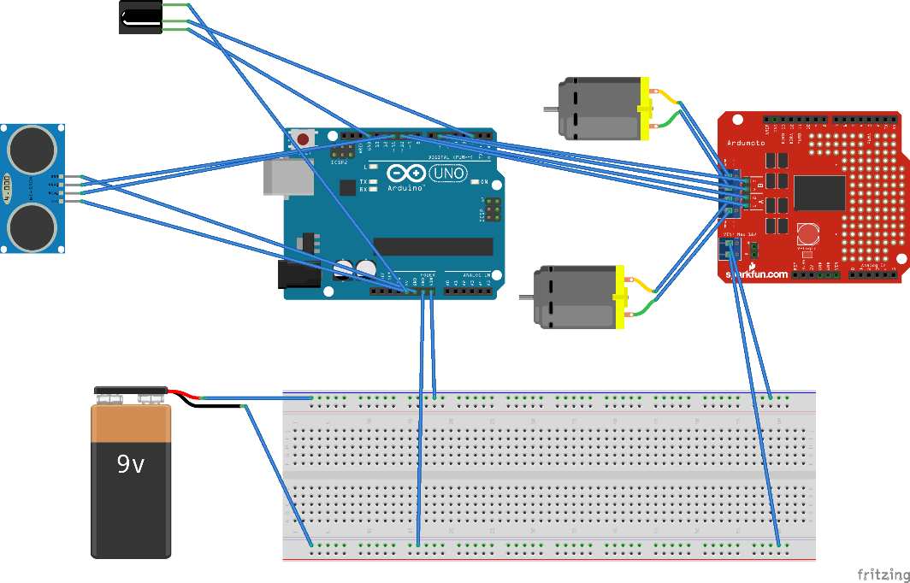

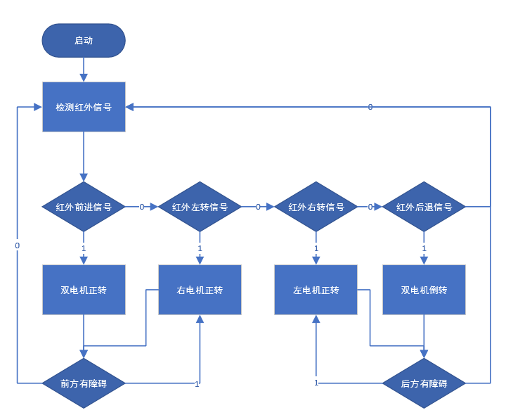

## Technology Route

## Platform

The system adopts the Arduino development board based on ATMEGA328 microcontroller as the system control board to build the arduino-based Netflix robot. L298N is selected as the motor driver board to drive two 120:1 geared motors to control the robot movement. 1838 infrared receiver receives infrared signals to achieve remote control of the robot. Obstacle detection is carried out by sr04 ultrasonic module.

Board Name Operating Voltage Clock Speed Digital i/o Analogue Input PWM UART Programming Interface

|  |  |  |  |  |  |  |  |
| --- | --- | --- | --- | --- | --- | --- | --- |
| **板名称** | **工作电压** | **时钟速度** | **数字i/o** | **模拟输入** | **PWM** | **UART** | **编程接口** |
| Arduino Uno R3 | 5V | 16MHz | 14 | 6 | 6 | 1 | USB通过ATMega16U2 |

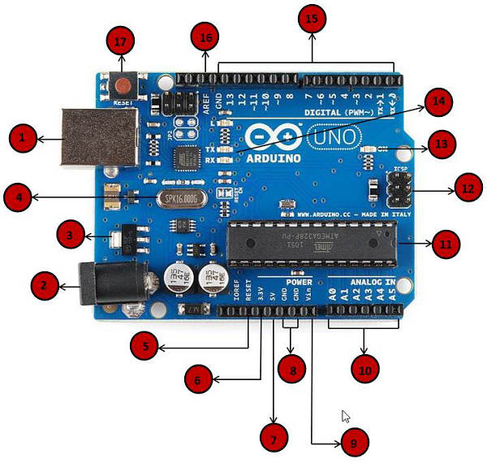

The HC-SR04 ultrasonic sensor uses sonar to determine the distance to an object, just like a bat. It provides very good non-contact range detection with high accuracy, stable readings, and ease of use in sizes ranging from 2 cm to 400 cm or 1 inch to 13 feet.

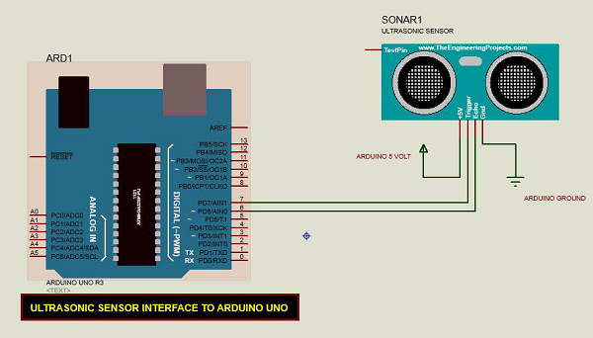

const int pingPin = 7; // Trigger Pin of Ultrasonic Sensor

const int echoPin = 6; // Echo Pin of Ultrasonic Sensor

void setup() {

Serial.begin(9600); // Starting Serial Terminal

// Starting Serial Terminal.}

void loop() { long duration, inches, cm; // Starting Serial Terminal }

long duration, inches, cm; pinMode(pingPin)

pinMode(pingPin, OUTPUT); digitalWrite(pingPin, LOW); // Starting Serial Terminal } void loop()

digitalWrite(pingPin, LOW); delayMicroseconds(2)

digitalWrite(pingPin, LOW); delayMicroseconds(2); digitalWrite(pingPin, LOW)

digitalWrite(pingPin, HIGH); digitalWrite(pingPin, LOW); delayMicroseconds(2)

pinMode(echoPin, INPUT); duration = pulseIn(echoPin, HIGH); delayMicroseconds(10)

duration = pulseIn(echoPin, HIGH); duration = pulseIn(echoPin, HIGH); pulseIn(echoPin, HIGH)

cm = microsecondsToCentimeters(duration);

Serial.print(inches);

Serial.print(inches); Serial.print(inches); Serial.print(inches); Serial.print(‘in,’);

Serial.print(inches); Serial.print("in, ’); Serial.print(cm);

Serial.print(cm); Serial.print(‘cm’).

Serial.println();

Serial.print(‘cm’); Serial.println(); delay(100);

}

long microsecondsToInches(long microseconds) {

return microseconds / 74 / 2; }

}

long microsecondsToCentimeters(long microseconds) { return microseconds / 29 / 2; }

return microseconds / 29 / 2; }

}

The distance measured by the sensor in inches and centimetres is displayed via the serial port.

The L298N is a dual H-bridge motor driver chip, where each H-bridge can provide 2A of current, the power section is supplied with a voltage range of 2.5-48v, and the logic section is supplied with 5v and accepts 5v TTL levels.

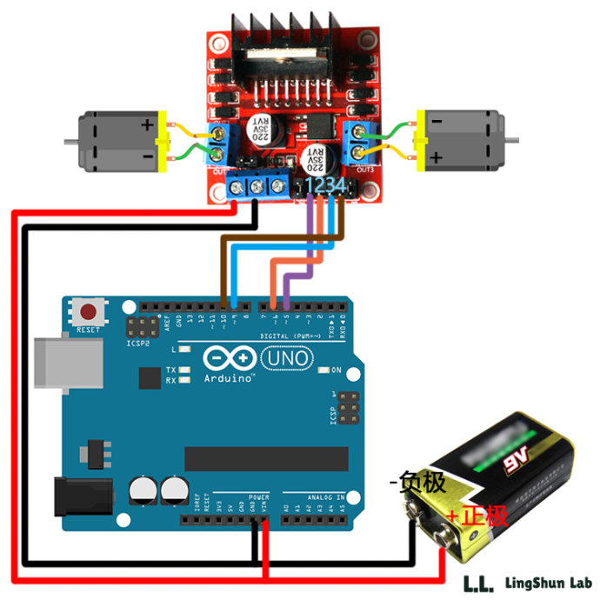

//LingShun Lab

int input1 = 5; // define pin 5 of uno to output to input1

int input2 = 6; // Define uno pin 6 to output to input2.

int input3 = 9; // define uno pin 9 to output to input3

int input4 = 10; // Define uno pin 10 to output to input4.

void setup() {

// Serial.begin (9600); // initialise the IOs.

// Initialise each IO to OUTPUT mode.

pinMode(input1,OUTPUT); pinMode(input2,OUTPUT).

pinMode(input2,OUTPUT); pinMode(input3,OUTPUT).

pinMode(input3,OUTPUT); pinMode(input4,OUTPUT).

pinMode(input4,OUTPUT).

}

void loop() {

//forward forward

digitalWrite(input1,HIGH); //give high level

digitalWrite(input2,LOW); //give low level

digitalWrite(input3,HIGH); //give it a high level

digitalWrite(input4,LOW); //give low level

delay(1000); //delay 1 second

//stop stop

digitalWrite(input1,LOW).

digitalWrite(input2,LOW).

digitalWrite(input3,LOW); digitalWrite(input4,LOW)

digitalWrite(input3,LOW); digitalWrite(input4,LOW); digitalWrite(input4,LOW)

//back Turn backward

digitalWrite(input1,LOW).

digitalWrite(input2,HIGH); digitalWrite(input3,LOW); //back

digitalWrite(input1,LOW); digitalWrite(input2,HIGH); digitalWrite(input3,LOW).

digitalWrite(input2,HIGH); digitalWrite(input3,LOW); digitalWrite(input4,HIGH).

}

#include <IRremote.h>

int PIN_RECV = 11; IRrecv irrecv(PIN_RECV); delay(1000)

IRrecv irrecv(PIN_RECV);

decode_results results.

void setup()

{

Serial.begin(9600); irrecv.enableIRIn(); void setup()

irrecv.enableIRIn(); void setup() { Serial.begin(9600); irrecv.

}

void loop() {

if (irrecv.decode(&results)) {

Serial.println(results.value);

irrecv.resume();

}

}

## Original list budget

Basic functional materials

Wooden boards several

Cardboard, some

Wires, some.

Motors two

Arduino uno development board one

1838 infrared receiver one

Infrared transmitter one

Sr04 ultrasonic module three

L298N dual circuit motor driver board, one.

120:1 gear motor two

Expansion Materials